ROWTOR ROCKS – The Druid Inn

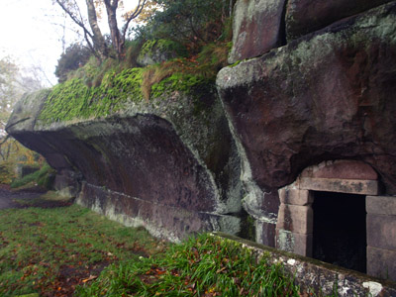

ROWTOR ROCKS at Birchover was explained to Victorian sightseers as an ancient Druid stronghold but the only local connection with Druids was the Druid Inn which was a meeting place for the Ancient Order of Druids, a friendly society founded in 1781.
Carved in and through the gritstone of Rowtor Rocks are caves, rooms, alcoves, tunnels, flights of worn stone steps, a stone armchair, a square font, cup and ring markings, rock basins and square sockets which may have supported crosses.
The views are now obscured by trees but nevertheless still impressive.
All of this extensive sculpting was the work of local parson Thomas Eyre three centuries ago.
At the eastern edge of the eighty yard gritstone ridge was a large rocking stone, weighing an estimated 50 tons, which could be moved by hand until, it is said that on Whit Sunday 1799 a gang of 14 young people pushed the stone off its pivot. The stone was replaced but the original balance could not be restored.

