Stanton Moor and Robin Hood’s Stride from Winster
Length | 7.0 miles / 11.4 km
Ascent | 1320 feet / 400 metres
Grade | easy/moderate
Start | OS grid reference SK241605  Lat 52.59748453833146 + Long -1.996441560068915  Postcode DE4 2DJ (approx. location only)
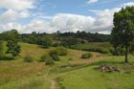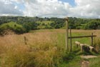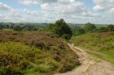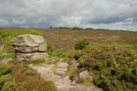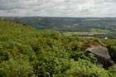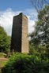
This route starts from the attractive village of Winster. It then explores Stanton Moor with its standing stones and other points of interest, before continuing via the village of Birchover with its unusual attraction and Robin Hood’s Stride back to the start.
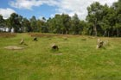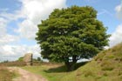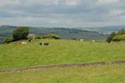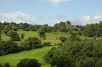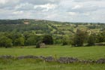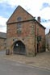
The walk starts from the village of Winster with its old Market Hall, the first property to be purchased by the National Trust, standing in the main street (Grid ref. SK241605). Standing in the street containing the Bowling Green Pub and with the Market Hall on your immadiate right, take the footpath signed to Birchover by the shop. This leads down to fields. Do follow the footpath signs and not what appears to be the way ahead. Following the path the route descends to a small valley. Bear right at the first footpath junction to climb out of the valley. At the next junction bear right again into a wood. The path climbs through the wood and turns sharp left to reach Clough lane (Grid ref. SK243617).
Go straight over and continue to barn farm. Excellent signage diverts you around the farm and leads you up to Lees Road (grid ref. SK245625). You now enter Stanton Moor. Follow the main path for a short way until the first major junction. Go right here and descend to a fence with an interesting outcrop of rock on the other side. (This can be accessed via a stile and offers a good view down into the Derwent valley.) Turn left along the fence and follow this path as it along the edge of Stanton Moor to reach a tower built in tribute to Earl Grey (of tea fame) who made a major contribution to the Reform Bill.
Cross over the stile and turn right. The path leads you to The Nine Ladies stone circle, one of over sixty Bronze Age sites on this moor. The single stone standing on its own on the other side is called The King Stone. Leave The Nine Ladies via the path to the south. This crosses Stanton Moor. Turn right at the path junction (Grid ref SK246628). This path takes you past the Cork Stone with footholds cut into its side. The path terminates at a road. Turn left and proceed down the road passing the entrance to a quarry. Just before the corner turn right onto a footpath by the car park. This drops down behind the houses of Birchover ending at a road opposite The Druid Inn.
Walk down the lane to the left of the Inn and look out for a very narrow path at the end of the Inn's car park. This leads up to Rowtor Rocks. The Reverend Thomas Eyre, a local vicar, carved these rocks to form caves, steps, armchairs and rooms. A word of warning - there are many holes in the path and unguarded edges that could lead to a fall.
Return to the lane, go past the church. At the next junction go straight ahead on the track. When the track doubles back on itself, go straight ahead and contour across the hillside with woods to your left. To your right, across the valley, you can see the outcrops that form Robin Hood’s Stride. From here they look like the roof and chimney of a cottage. Take the next path on your right (Grid ref SK230620) and descend to the road. Turn left along the road taking care as it can be quite busy. After 200 metres turn right up the track and continue towards Robin Hood’s Stride. It is worth exploring a little perhaps visiting the Hermit’s cave located on a side path that goes to your right.
Exploration complete, return to the main road and turn right up Dudwood Lane. This is part of the Limestone Way, which will be followed for much of the way back to Winster. The lane climbs steadily. Go straight across at the first road junction (Chadwick Hill) and continue along the lane. On your left there are views across much of the route covered so far. Reaching another road (Grid ref SK236600), turn left. On the other side of the main road, locate the signed footpath leading east.
Take this footpath and after approximately 200-300 metres look out for an unsigned path on your right. The only clue is a stile. Cross this and descend the field exiting onto a road (note the exit stile is adjacent to the building in the bottom right hand corner of the field). Turn right along this road passing many attractive cottages. Eventually the road bears left and leads you back down to the Market Hall and the centre of Winster.

